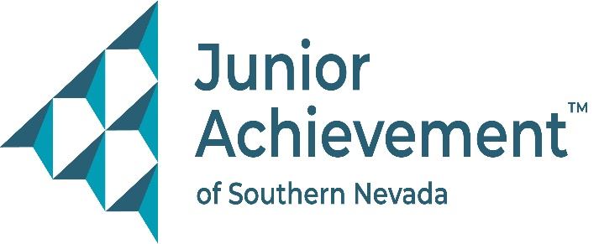

Date
FOR IMMEDIATE RELEASE:

Junior Achievement of Southern Nevada Welcomes Philip Natale from
Merrill Lynch Bank of America to Board of Directors



LAS VEGAS – Junior Achievement of Southern Nevada (JASN) is thrilled to announce the appointment of Philip Natale, a senior financial advisor and vice president at Merrill Lynch Bank of America, to its board of directors. With a wealth of experience in the financial sector and a deep passion for education and community service, he will bring invaluable expertise and dedication to the nonprofit organization’s mission of empowering young people through financial literacy, workforce readiness, and entrepreneurship.

A Las Vegas native, Natale holds a Bachelor of Science in Economics from the University of Nevada, Las Vegas. His professional journey includes more than a decade of experience in the financial industry, with roles at Wells Fargo Advisors and Merrill Lynch Bank of America across both Nevada and New York. Currently based in Southern Nevada, Natale leverages his extensive knowledge of finance to advise clients on achieving long-term financial success.

Inspired by his upbringing, faith, and educators who guided him, Natale’s desire to give back to the community fuels his commitment to Junior Achievement. “Financial literacy is imperative,” he said. “I witnessed firsthand the damage caused by a lack of education during the 2008 financial crisis. I’m determined to help the next generation avoid those pitfalls and contribute to building a stronger, more resilient Las Vegas.”

Natale’s strong connection to the area, both personally and professionally, has shaped his belief in the city’s potential for growth and transformation. He reflects on the city’s recovery from the 2008 economic downturn with optimism, noting how the crisis led to Southern Nevada’s evolution into a more robust and diversified economy.

"We are excited to have Philip on our board of directors," said Michelle Jackson, JASN president and CEO. "His passion for teaching financial literacy and his commitment to helping our community thrive align perfectly with Junior Achievement’s goals. Philip’s leadership will help us continue to inspire and educate the next generation of leaders in Southern Nevada."

Outside of his career, Natale is devoted to his family and friends, including his rescue dog of 11 years. He actively participates in volunteer work and is motivated by his faith to help others every day, whether through his career or community engagement.

About Junior Achievement of Southern Nevada
Founded locally in 1996, Junior Achievement of Southern Nevada, Inc. is dedicated to providing financial education to K-12 students and young adults with a curriculum including wants vs. needs, budget management to economic principals, workforce skills, credit and entrepreneurship. The completion of the new 40,000-square-foot Junior Achievement of Southern Nevada Inspiration Center will allow the nonprofit organization to impact more than 60,000 local youth. It is now the permanent site for capstone programs, Betty’s JA BizTown and JA Finance Park. Junior Achievement of Southern Nevada’s financial literacy mission is accomplished with the support of 285 businesses and 6,800 business role models, who help youth learn about the “business of life,” by helping bridge the gap between what youth learn in school and the real world. For more information visit https://jasnv.org/ and follow on Instagram and Facebook.

About Junior Achievement USA® (JA)
Junior Achievement is the world's largest organization dedicated to giving young people the knowledge and skills they need to own their economic success, plan for their future, and make smart academic and economic choices. JA programs are delivered by corporate and community volunteers, and provide relevant, hands-on experiences that give students from kindergarten through high school knowledge and skills in financial literacy, work readiness and entrepreneurship. Today, JA reaches 4.5 million students per year in 115 markets across the United States, with an additional 5.8 million students served by operations in 120 other countries worldwide. Visit www.ja.org for more information.

# # #
MEDIA CONTACT:
Nancy Katz, Purdue Marion & Associates, 702-349-0063 or nancy@purduemarion.com

